ST. XAVIER’S COLLEGE

**(Affiliated to Tribhuvan University)**

**Maitighar, Kathmandu**

****

**Database Management System**

**Theory Lab Assignment #4**

**SUBMITTED BY:**

Sneha Prasai

013BSCCSIT040

**SUBMITTED TO**

|  |  |
| --- | --- |
| **Mr. Sanjay Kr. Yadav**  **( Lecturer )** |  |
| **Department of Computer Science** | |

1. **ER diagram with one case study.**

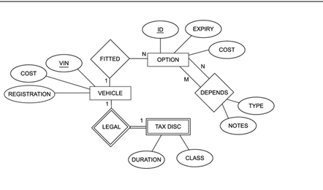  
fig: ER diagram

1. **Design:**

Design process:

* Determine the purpose of the database
* Find and organize the information required.
* Divide the information into tables
* Turn information items into columns
* Specify primary keys
* Set up the table relationships
* Refine the design
* Apply the [normalization rules](https://en.wikipedia.org/wiki/Database_normalization)
  1. Functional Design:
* Functional Design is a paradigm used to simplify the design of hardware and software devices such as computer software and increasingly, 3D models.
* A functional design assures that each modular part of a device has only one responsibility and performs that responsibility with the minimum of side effects on other parts.
* The advantage for implementation is that if a software module has a single purpose, it will be simpler, and therefore easier and less expensive, to design and implement.
* Systems with functionally designed parts are easier to modify because each part does only what it claims to do.
* Since maintenance is more than 3/4 of a successful system's life,[[1]](https://en.wikipedia.org/wiki/Functional_design" \l "cite_note-1) this feature is a crucial advantage. It also makes the system easier to understand and document, which simplifies training. The result is that the practical lifetime of a functional system is longer.
* In a system of programs, a functional module will be easier to reuse because it is less likely to have side effects that appear in other parts of the system.
  1. **Database Design:**
* Database design is the process of producing a detailed data model of a database.
* This logical data model contains all the needed logical and physical design choices and physical storage parameters needed to generate a design in a data definition language, which can then be used to create a database.
* A fully attributed data model contains detailed attributes for each entity.
* The process of doing database design generally consists of a number of steps which will be carried out by the database designer. Usually, the designer must:
  + Determine the relationships between the different data elements.
  + Superimpose a logical structure upon the data on the basis of these relationships.
    1. Conceptual Database Design:
* Once a database designer is aware of the data which is to be stored within the database, they must then determine where dependency is within the data.

Sometimes when data is changed you can be changing other data that is not visible.

* For example, in a list of names and addresses, assuming a situation where multiple people can have the same address, but one person cannot have more than one address, the address is dependent upon the name. When provided a name and the list the address can be uniquely determined; however, the inverse does not hold - when given an address and the list, a name cannot be uniquely determined because multiple people can reside at an address. Because an address is determined by a name, an address is considered dependent on a name.
  + 1. Logical Database Design:
* Once the relationships and dependencies amongst the various pieces of information have been determined, it is possible to arrange the data into a logical structure which can then be mapped into the storage objects supported by the database management system.
* In the case of relational databases the storage objects are tables which store data in rows and columns.
  + 1. Physical Database Design:
* The physical design of the database specifies the physical configuration of the database on the storage media.
* This includes detailed specification of data elements, data types, indexing options and other parameters residing in the DBMS data dictionary.
* It is the detailed design of a system that includes modules & the database's hardware & software specifications of the system.